PRACTICAL 3:

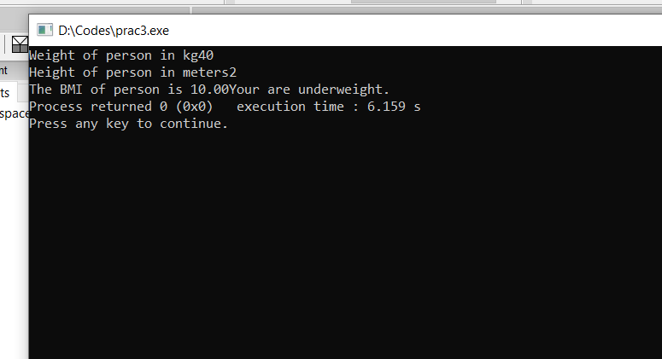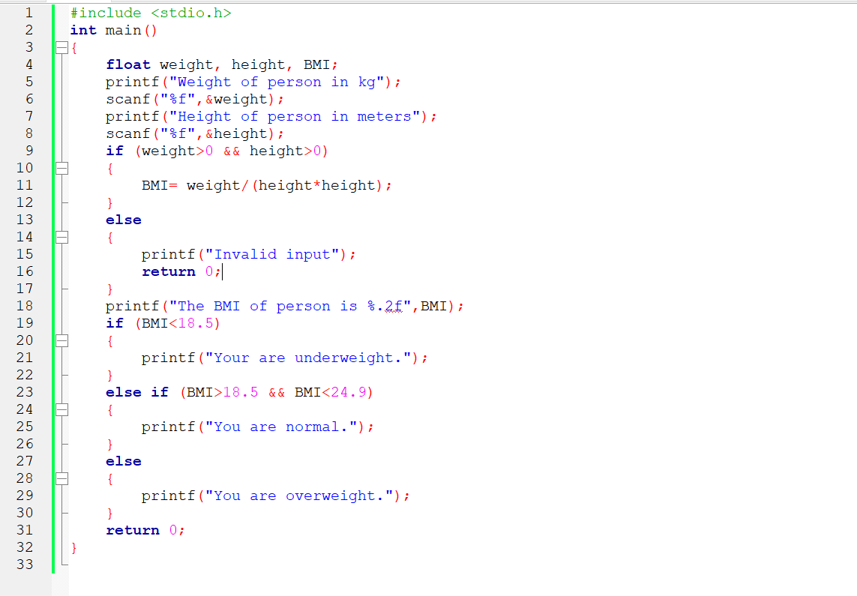TO CACULATE BODY MASS INDEX OF A PERSON